MY PAST/PRESENT STUDENTS’ ACHIEVEMENTS
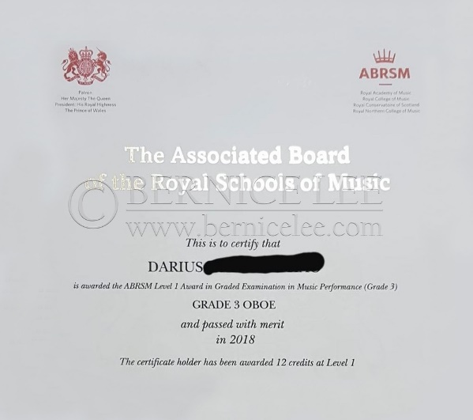

2018 ABRSM Grade 3 Oboe (Merit)

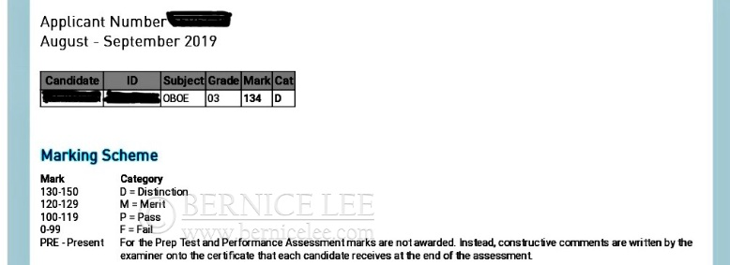

2019 ABRSM Grade 3 Oboe (Distinction)

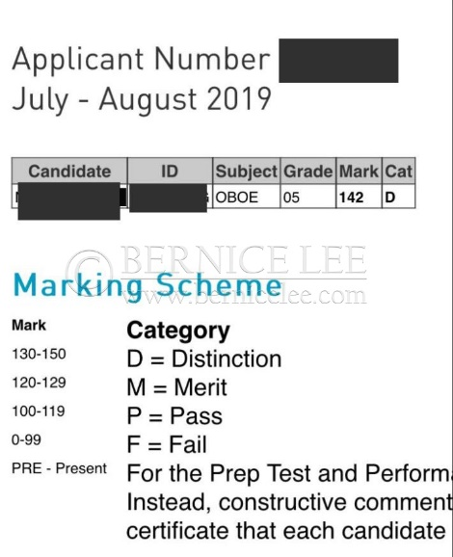

2019 ABRSM Grade 5 Oboe (Distinction)

